[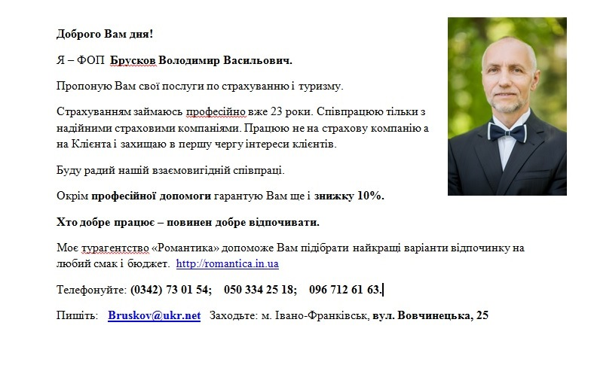](file:///C:\Users\User\Documents\111.docx)